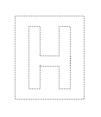 | TEMASEK JUNIOR COLLEGE, SINGAPORE  Preliminary Examination 2012  Higher 2
MATHEMATICS |  |  | 9740/01
Paper 1
 |  |  | 13 September 2012
Additional Materials: | Answer paper |  | 3 hours
 | List of Formulae (MF15)
READ THESE INSTRUCTIONS FIRST
Write your Civics group and name on all the work that you hand in.
Write in dark blue or black pen on both sides of the paper.
You may use a soft pencil for any diagrams or graphs.
Do not use staples, paper clips, highlighters, glue or correction fluid.
Answer all the questions.
Give non-exact numerical answers correct to 3 significant figures, or 1 decimal place in the case of angles in degrees, unless a different level of accuracy is specified in the question.
You are expected to use a graphic calculator.
Unsupported answers from a graphic calculator are allowed unless a question specifically states otherwise.
Where unsupported answers from a graphic calculator are not allowed in a question, you are required to present the mathematical steps using mathematical notations and not calculator commands.
You are reminded of the need for clear presentation in your answers.
The number of marks is given in brackets [ ] at the end of each question or part question.
At the end of the examination, fasten all your work securely together.

This document consists of 6 printed pages.


© TJC 2012 |  | [Turn over

1 An ellipse E has equation

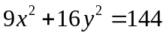.

- Find 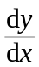 in term of x and y. [1]

- Show that the point P with coordinates ( 4cosθ, 3sinθ ) lies on E. [1]

(iii) Find the equation of the normal to the ellipse E at the point P, in the form of 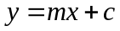 where m and c are single trigonometric expressions of θ. [3]

2 Consider the equation
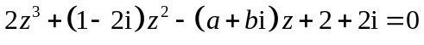,
where a and b are real.

Given that  is a root of the equation, find the values of a and b. [3]

Given also that 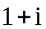 is another root, find the third root of the equation. [3]

3 HIMHEYS' Confectionery recently created three types of chocolate: Organic white, Organic milk and Organic dark, available in 250g bars. Cocoa butter, an essential ingredient in chocolate bars, makes up 25%, 20% and 15% of the mass of an Organic white, Organic milk and Organic dark chocolate bar respectively.

To prepare for the official launch of their chocolate bars at an upcoming Food Expo, HIMHEYS' decides to manufacture a total of 300 bars for the event, with more than 70 bars of each type.

The confectionary intends to use 14kg of cocoa butter in the production of the above batch of chocolate bars. If the number of milk chocolate bars is to be smaller than the number of white chocolate bars, determine how many organic chocolate bars of each type can be produced. [6]

4 Referred to an origin O, the position vectors of two points A and B are a and b respectively. The points P on OA and Q on AB are such that OP = 2PA and 5AQ = 4QB. Show that the equation of the line l passing through P and Q can be written as
r = 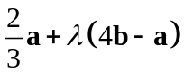, . [4]

The point X on l is such that AX is perpendicular to l. If 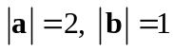 and a is perpendicular to b, show that the position vector of X is 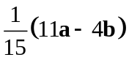. [4]

[Turn over
5 The functions f and g are defined by
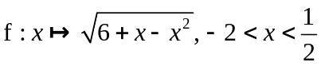,
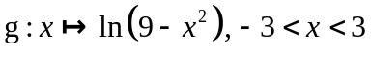.
Determine whether each of the following functions exists and give a definition (including the domain) of the function if it exists.
(a) 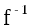,
(b) 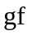. [9]

6 Given that 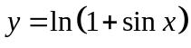, show that

(i) 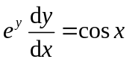, [2]

(ii) 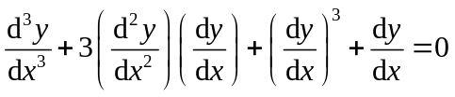. [3]

Find the Maclaurin’s series for y up to and including the term in x³. [3]

Hence, or otherwise, show that 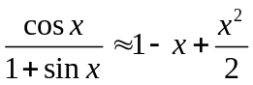. [2]

7 (a) A finite arithmetic progression has n terms and common difference d. The first term is 1 and the sum of the last 5 terms exceeds the sum of the first 4 terms by 193.

(i) Show that 5nd− 21d−192 = 0. [3]

(ii) Given also that the 6th term of the progression is 16, find n. [2]

(b) A sequence U is formed in which the n^{th} term is given by 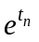where is the n^{th} term of an arithmetic progression with first term =1.

(i) Show that U is a geometric progression. [2]

(ii) Given that the sum to infinity of even-numbered terms of U is 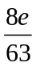, find the common ratio of U. [3]

[Turn over
8 The point A has position vector 3j − 4k with respect to an origin O.

The plane 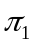 has Cartesian equation 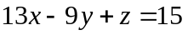.

(i) If 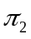 is a plane parallel to and contains the point A, write down the equation of in scalar product form and find the distance from the origin O to. [3]

(ii) Hence or otherwise, find the distance between 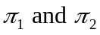. State with clear explanations whether O and A are on the same side of 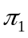. [3]

(iii) Another plane 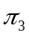 has Cartesian equation 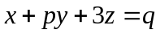. If 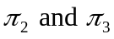 intersect at a line containing A and is perpendicular to , find the value of p and q. [4]

9 (a) Prove by induction that

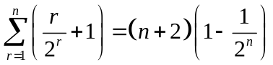 . [5]

(b) Show that 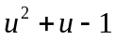 can be written in the form 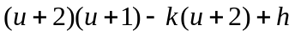 where and are positive constants to be determined. [2]

Hence show that 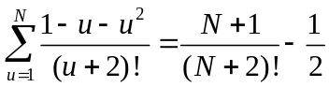 . [4]

[Turn over
10
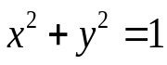
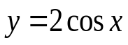
y
x
R

The diagram shows the region R bounded by the x-axis and the two curves 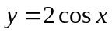 and .

(i) Find the exact area of the region R. [3]

(ii) Using integration by parts, show that

where C is a real constant. [2]

(iii) The region R is rotated π radians about the -axis to form a solid of revolution S. Show that the volume of S can be expressed as

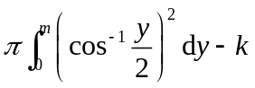,

where m and k are exact values to be determined. [3]

Hence, by using the substitution 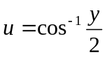 and the result in part (ii), find the exact value of the volume of S. [4]

[Turn over
11 (a) Show that

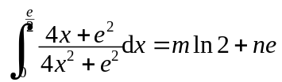,

where m and n are exact values to be determined. [6]

(b) In an experiment to study the spread of a soil disease, an area of 15 m² of soil was exposed to infection. In a simple model, it is assumed that the infected area grows at a rate which is proportional to the product of the infected area and the uninfected area. Initially, 5 m² was infected and the rate of growth of the infected area was 0.1 m² per hour. At time t hours after the start of the experiment, an area x m² is infected.

(i) Show that 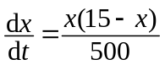. [2]

(ii) Solve the differential equation and express t in terms of x. [4]

(iii) Find the minimum time in hours needed for 95% of the soil area to become infected. [1]

   End of Paper   

